**Aim**

Design an automatic night lighting system such the system is only activated when the master control switch is pressed.

a) Below 50% value of full brightness led blinks with a freq. of 500 msec.

b) Above 50% value of full brightness led blinks with a freq. of 100 msec.

**Apparatus Required**

1. Arduino UNOR3
2. Breadboard
3. Connecting wires
4. 1 Resistor of 10K ohm
5. 1 Resistor of 331 ohm
6. 1 LED
7. LDR(Light dependent resistor)

**Circuit Diagram**

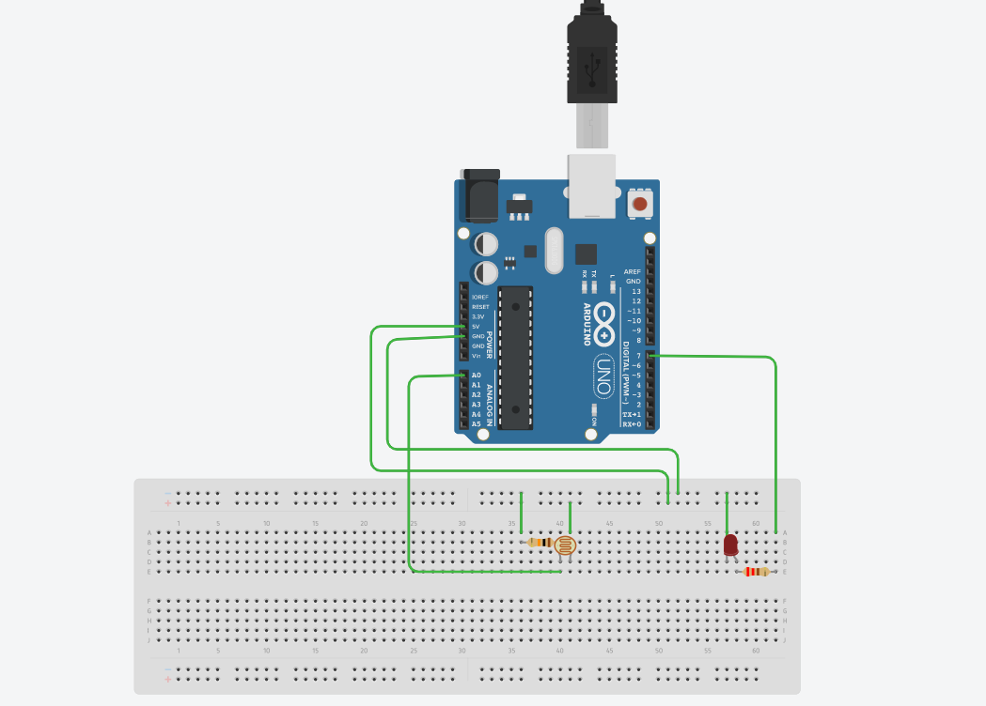

**CODE**

#define relay 10

int LED = 7;

int LDR = A0;

void setup()

{

Serial.begin(9600);

pinMode(7, OUTPUT);

pinMode(relay, OUTPUT);

pinMode(A0, INPUT);

}

void loop() {

int LDRValue = analogRead(A0);

Serial.print("sensor = ");

Serial.print(LDRValue);

if (LDRValue <=700)

{

digitalWrite(7, HIGH);

digitalWrite(relay, HIGH);

Serial.println("It's Dark Outside; Lights status: ON");

}

else

{

digitalWrite(7, LOW);

digitalWrite(relay, LOW);

Serial.println("It's Bright Outside; Lights status: OFF");

}

}

**Result**

Hence the led automatically turn on when the night starts and the led automatically turn off in the morning . Led also blinks when the brightness of the below 50% it blinks with the speed of 500 milliseconds and it also blink with the speed of 100 milliseconds when the brightness is above 50%.